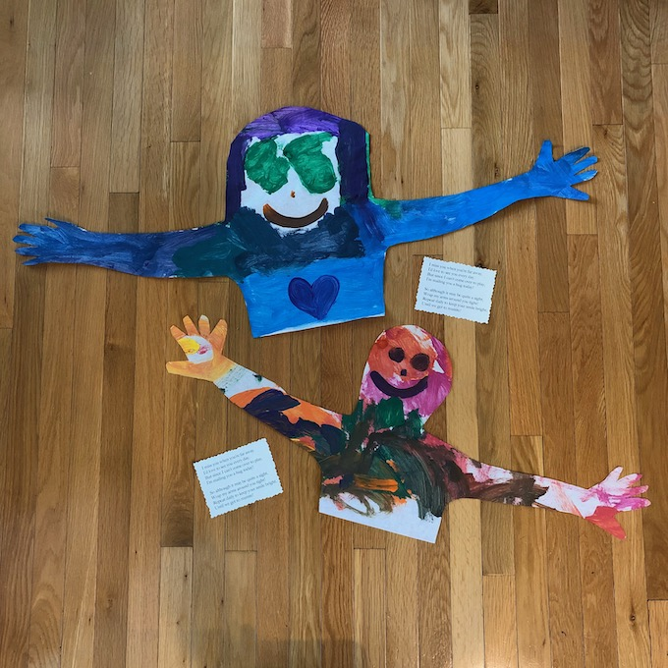
A Mail Hug
God Loves YOU so much. This is a special way to share with others just how much you love them. You can love others because God loves you. The bible tells us in 1 John 4:19, “We love each other because He loved us first.”
Use your “Mail Hug” to tell others to how much God loves them.
Inside this envelope you will find a large piece of paper, three scripture cards and an envelope to mail your “Hug” to someone you love.

Here are your directions:
- Spread out the long sheet of butcher paper. Lay down on the paper.

- Ask your parents to trace around you head, arms, and upper torso onto the paper.
- Now it’s time to get creative. Make the picture look just like you. You can use crayons, felt pens, or paint to decorate the picture. Then cut it out.

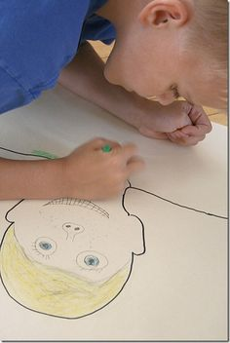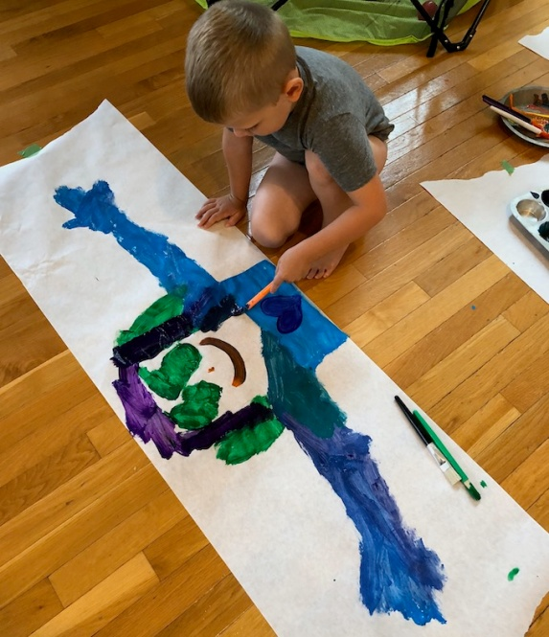
- Cut out the three scripture cards. Glue a card on the inside of both hands and glue the third card where your heart might be in the picture.

- Carefully fold up your “Mail Hug” picture so it will fit into the envelope. Ask your parent to help you write the address on the envelope and mail it to someone you love!

Scripture Cards
We love each other because
He loved us first.
1 John 4:19

We know how much
God loves us,
and we have put our trust
in His love.
1 John 4:16a

The faithful love of the LORD never ends!
His mercies never cease.
Lamentations 3:21

1 John 4:9-11
God showed how much he loved us by sending his one and only Son into the world so that we might have eternal life through him. This is real love - not that we loved God, but that he loved us and sent his Son as a sacrifice to take away our sins.
Dear friends, since God loved us that much, we surely ought to love each other.
Thank you for sharing God’s love with someone you love.

